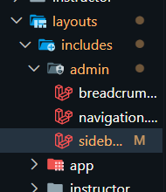
Modificacion sidebar
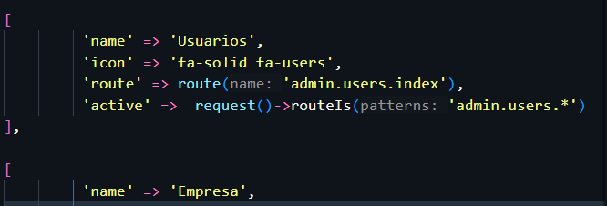

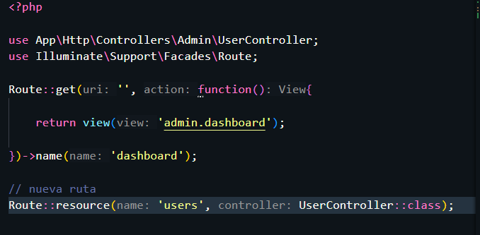

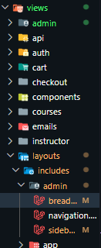
Admin / breadcrumb

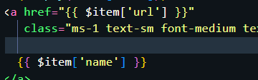

Tablas
https://rappasoft.com/docs/laravel-livewire-tables/v4/start/installation

composer require rappasoft/laravel-livewire-tables

https://rappasoft.com/docs/laravel-livewire-tables/v4/start/configuration
php artisan vendor:publish --provider="Rappasoft\LaravelLivewireTables\LaravelLivewireTablesServiceProvider" --tag=livewire-tables-translations

poner esto en tailwind
// V3
module.exports = {
content: [
...
'./vendor/rappasoft/laravel-livewire-tables/resources/views/**/*.blade.php',
]
.
php artisan make:datatable UserTable User
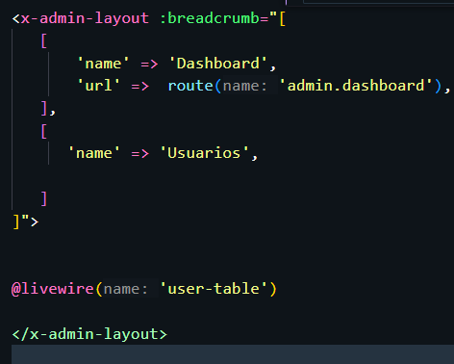

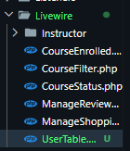
Aca esta el userTable

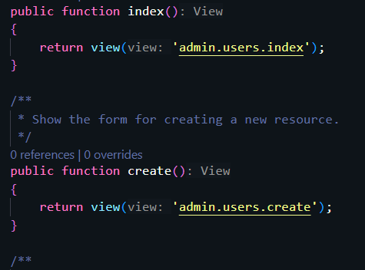
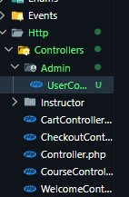
Controlador

action
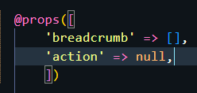
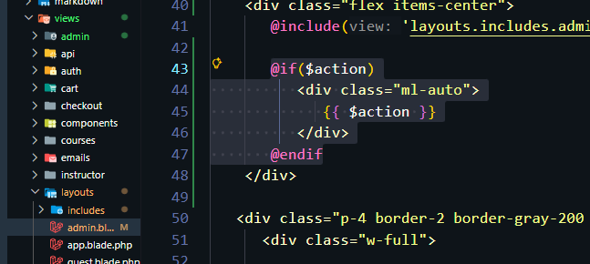

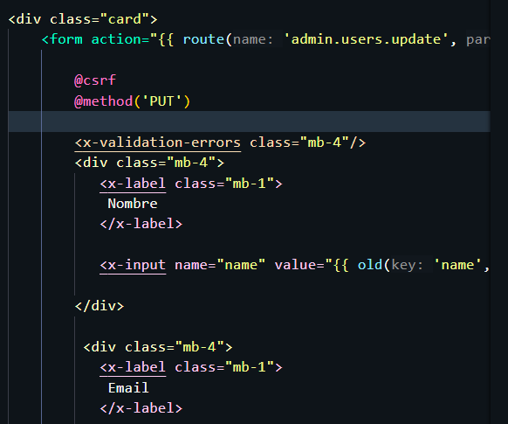
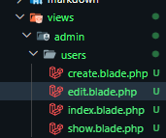
EDITAR

